**Name:** Vineel Sai

**Reg No:** 498

**IIIT Kalyani, Assignment 1 8081 Micro controller**

**PROB.1** ADD THE NUMBERS 0FH AND F0H.STORE THE RESULT IN 34H.

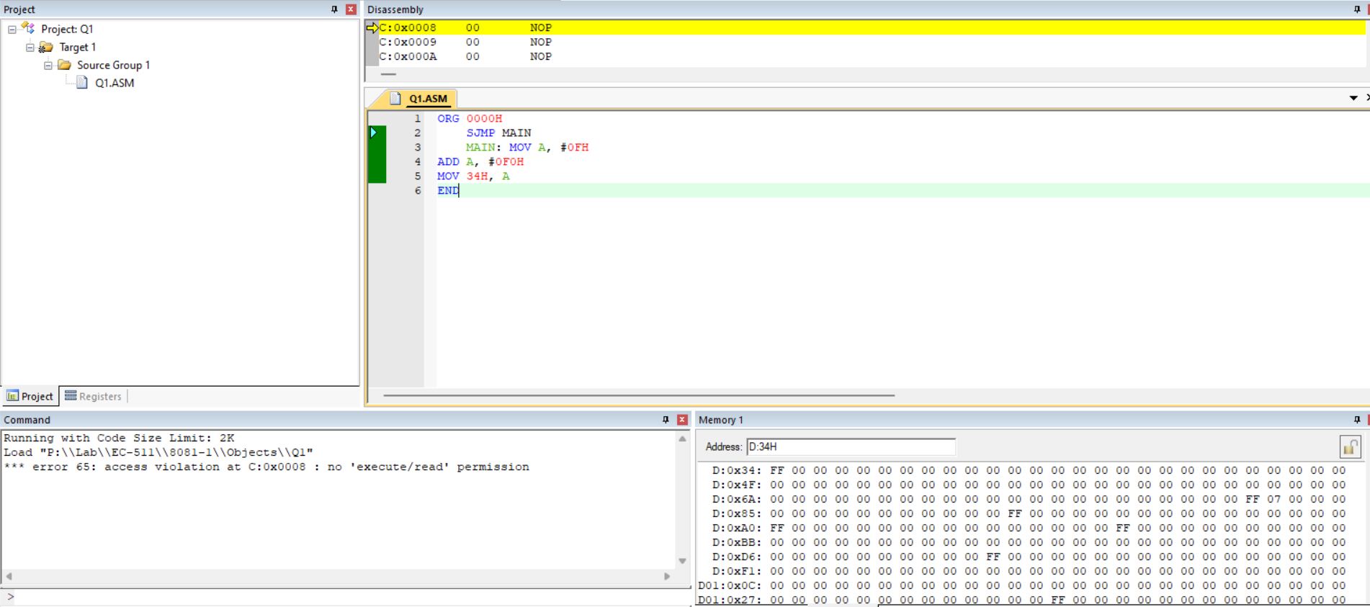

**PROB.2** TWO NUMBERS ARE STORED IN 34H AND 35H. PERFORM ADDITION AND STORE THE LOWER BYTE OF THE RESULT IN 36H AND UPPER BYTE OF THE RESULT IN 37H.

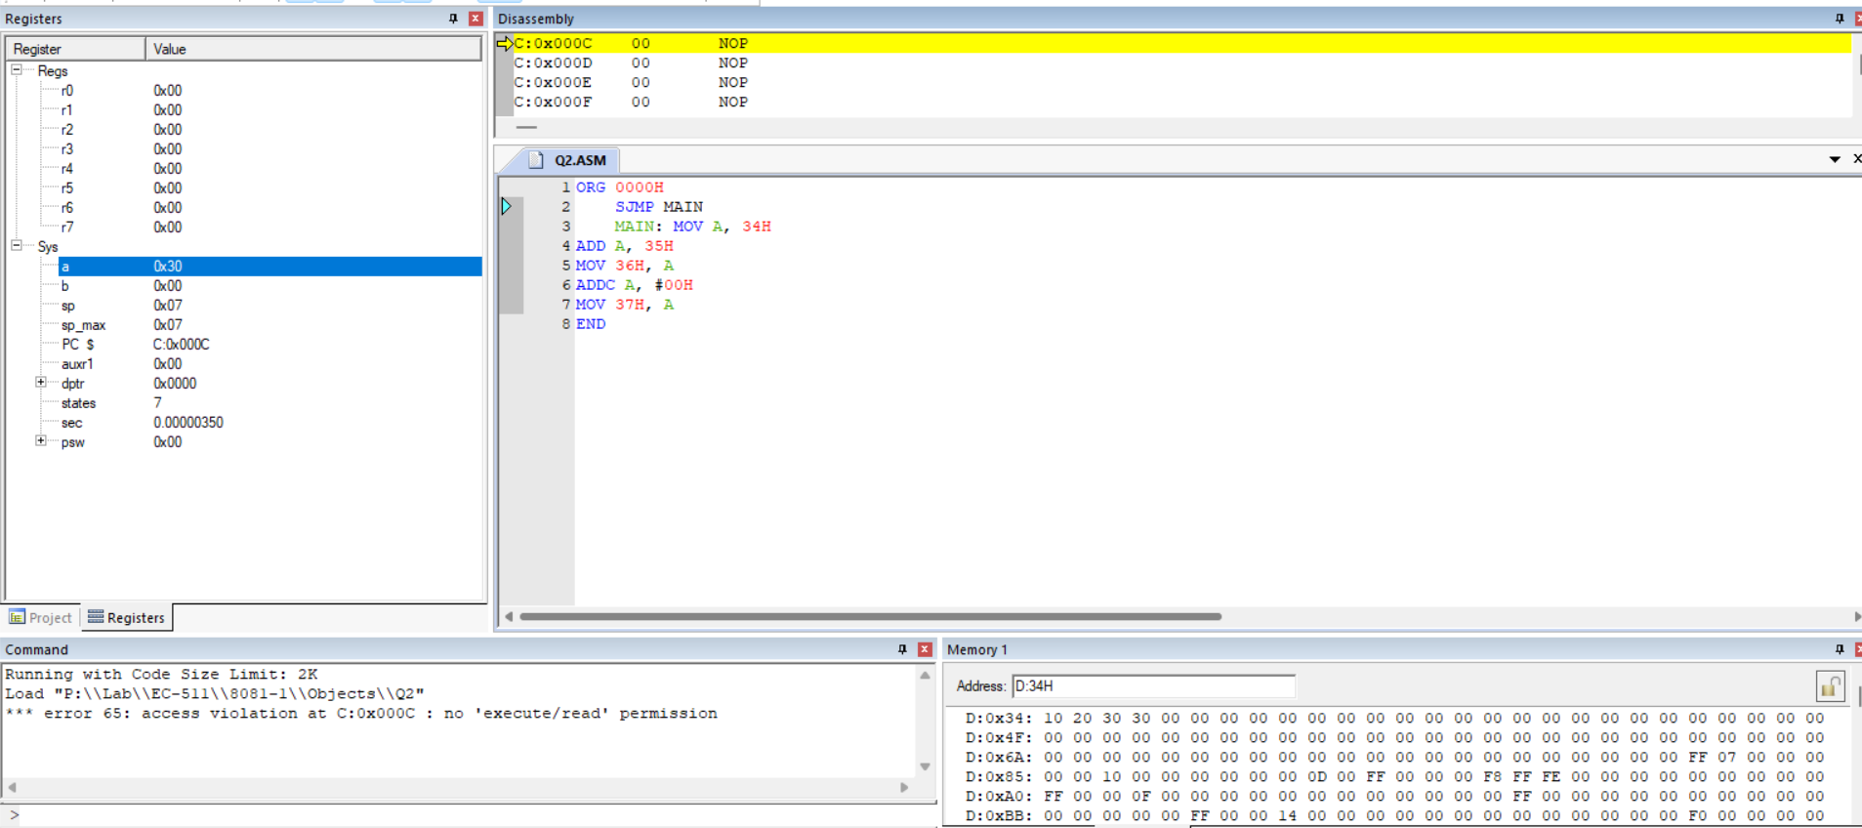

**PROB.3** TWO NUMBERS ARE STORED IN 34H AND 35H. PERFORM

MULTIPLICATION/DIVISION AND STORE THE RESULT IN 36H AND 37H.

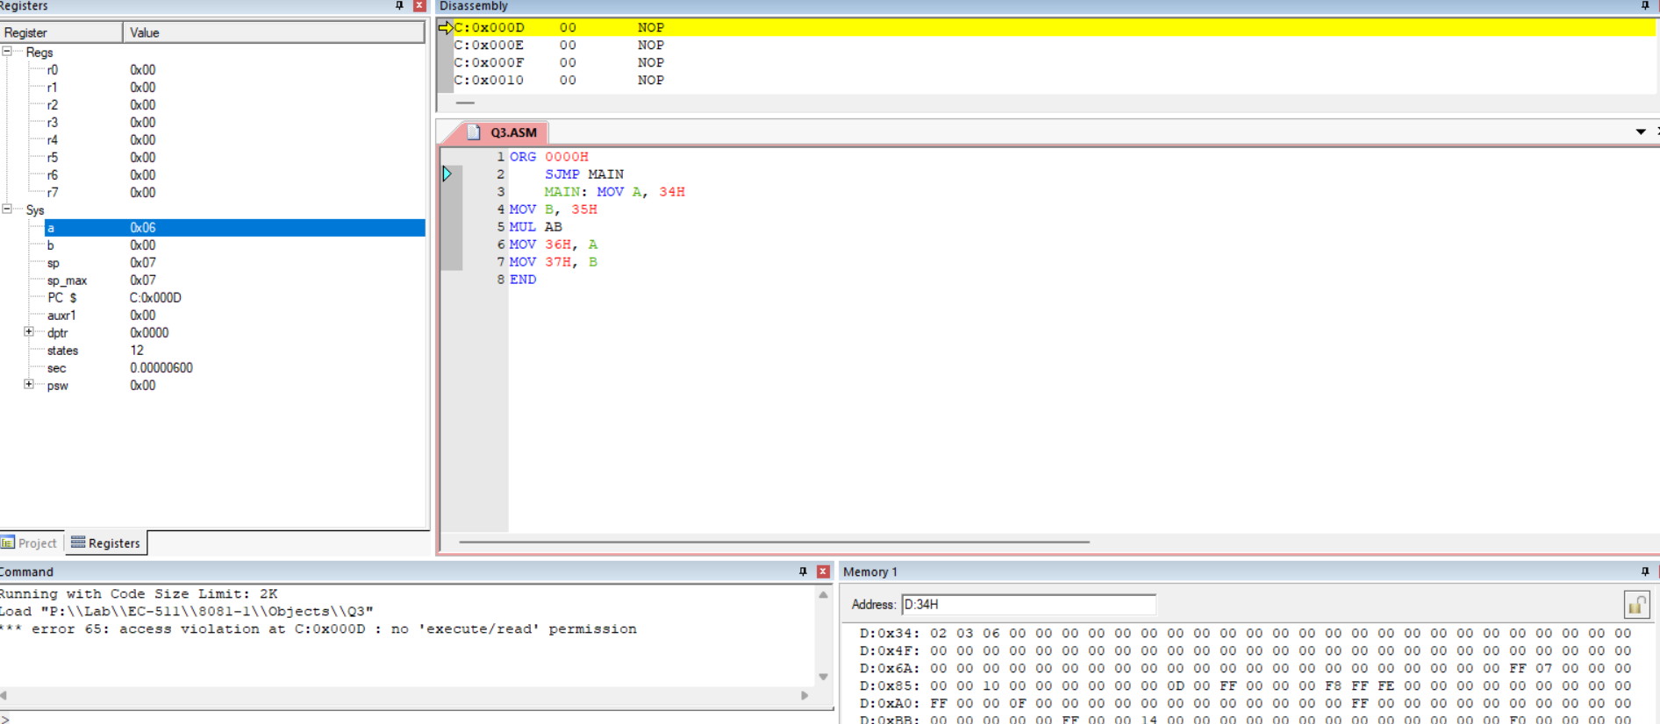

**PROB.4** DIVIDE THE CONTENT OF R0 BY R1. STORE THE RESULT IN R2 (Q) AND R3(R). THEN RESTORE THE ORIGINAL CONTENT OF R0.

